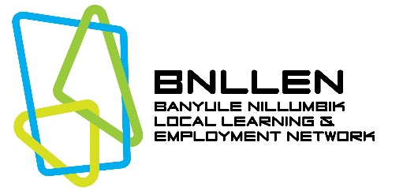
STUDENT APPLICATION FORM
AUSTIN HEALTH – 2024

Austin Health, together with Banyule Nillumbik Local Learning and Employment Network (BNLLEN) facilitate quality workplace learning placements including: Structured Workplace Learning and Work Experience.

PLACEMENT DETAILS:
Placement Type  (Please select one) | Structured Workplace Learning |  | Work Experience
Department/  Area of Interest | 1…………………………………  2…………………………………  3………………………………… | Preferred date/s for placement  (1 week block)

STUDENT EDUCATION DETAILS:
First Name:  (Given name) |  |  | Last Name:  (Family name)
School Name and Address
Careers Coordinator Name
Careers Coordinator Email |  |  |  | Phone
Comments: (CAREERS COORDINATOR TO COMPLETE)
Year Level in 2024
Are you enrolled in a VET Program? Y/N? |  | If Yes, Program Name & Certificate Level

IMPORTANT INFORMATION RELATING TO COVID-19 PANDEMIC
The student placement program is managed by the Banyule Nillumbik Local Learning Network (BNLLEN).
- Please direct all enquiries to BNLLEN
- Please do not contact Austin Health HR with enquiries about SWL or Work Experience

Limited numbers of Structured Workplace Learning (SWL) placements continue to be offered for students enrolled in a related VET Certificate only, including Cert III Allied Health Assistance or Health Assistance Services. The Work Experience Program at Austin Health was paused indefinitely as a result of the Covid-19 pandemic. Very limited places may be available in 2024 while the capacity of the program is re-established and Covid-19 related restrictions still apply. It is a requirement that students considering placement are vaccinated against Covid-19 with one of the approved vaccines and according to age recommendations. Whilst on placement students must adhere to all OH&S directions given by their supervisors. It remains the responsibility of schools and students to ensure that their own Child Safe policies are adhered to.

STUDENT PERSONAL DETAILS:
First Name: |  |  | Last Name
Home Address |  |  | Suburb &  Post Code
Mobile |  |  | Home Phone
Student Email
Languages Spoken |  |  | Date of Birth
Parent/Guardian Name |  |  | Parent/Guardian Phone
Do you require extra support in the workplace?
Eg. Access needs, extra breaks, language support or other. If YES, please specify.
Are you Aboriginal or Torres Strait Islander (ATSI)?
Are you applying for the ATSI Careers in Health Week?
(ATSI students only.) Date for 2024 to be confirmed.
Please list any relevant Occupational Health & Safety Training you have undertaken:

What skills and personal attributes would you bring to this position?

Any other relevant information?

Please Note: Incomplete or unreadable forms will be returned unprocessed. Please submit as Word or PDF only (unreadable files including jpegs, gifs, pages or external links will not be processed.) Submission of the application form does not guarantee placement. You will be contacted should your application be successful. Meanwhile, it is best to continue contacting other potential host employers.

Please email Application & Resume to:
BNWL Program Officer
E: bnwl@bnllen.org.au

